User Guide

This user guide is built on the assumption that the Music Player interface has been opened and loaded by the user. The other assumption is the user has loaded their audio files into the “music” directory inside the Build_v1 directory.

# Adding Audio Tracks



1. 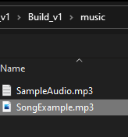Click the Plus button to open the file explorer and select an audio file.

# Navigating the Playlist



1. Click the Three-line menu button to open the playlist.
2. 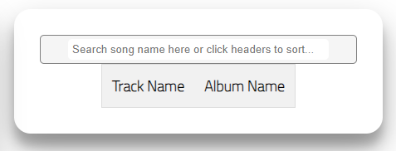Enter text into the search bar to find a track name.
3. Click either of the headers to order tracks alphabetically by Track Name or Album Name (Can be either ascending or descending).

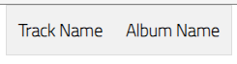

# Playback Control

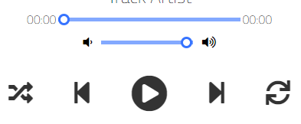

1. -->
2. -->
3. -->
4. -->
5. -->
6. -->
7. -->
8. Seek slider – Click and drag this along to change where the current song is at.
9. Volume slider – click and drag this along to change the output volume of the music player.
10. Shuffle – Click this to play the next songs in a random order, click again to play songs in regular playlist order.
11. Previous – Click this to play the previous song.
12. Play/Pause – Click to play or pause current song.
13. Next – Click this to play the next song.
14. Repeat – Click this to restart the current song from the beginning.